1. and 2.



3. and 4.

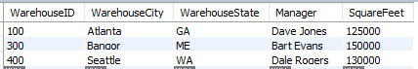

5.



6.

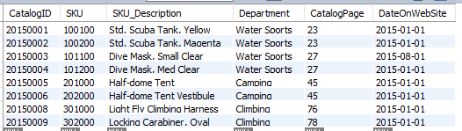

7. Note the column name for EmailAddress will likely be different in your result unless you use a column alias. Your column name does not need to match.

